**CHAPTER I**

**PROJECT LOCATION AND DESIGN BUILDING ORIENTATION**

**Introduction**

Air Conditioning has a big importance to daily lives to make sure everyone feel comfotable and happy while working hard. For hospital, it needs a functional Air-Conditioning System to stay operational. This is especially true for places like a clean room or an operating room. It provides a broad range of services in support of populations who are uniquely vulnerable to an elevated risk of health, fire, and safety hazard. These heavily regulated, high-stakes facilities undergo continuous maintenance, verification and inspection; typically operate 24hours/day, 7hours/week; and are health care organization for long life cycles. Hospital facilities and services are characterized by high rates of modification because of the continuously evolving science and economics of health care, and consume large quantities of energy and potable water. The often unique environmental conditions associated with these facilities, and the critical performance, reliability and maintainability of Air-Conditioning Systems necessary to their success, demand a specialized set of engineering practices and design criteria established by technical standards and guidelines like in accordance with the procedures outlined in the American Society of Heating, Refrigerating, and Air-Conditioning Engineers (ASHRAE) Handbook of Fundamentals.

It is important to follow the design considerations for the hospital to create a comfortable environment for occupants and patients. Hospital air conditioning and ventilation systems are tasked with controlling temperature, air flow, air quality and humidity. It is essential to the healing and recovery process. Also, it works with in close coordination with specific medical practices. One example for the design of operating rooms which has specific requirements that include pressurization and higher levels of air filtration in addition to temperature and humidity control.

The design of the Three Storey Hospital Building would most be beneficial to the patients who are injured and sick and provide a comfortable environment in facilitating for healing and recovery. The design of the Air-Conditioning System would also benefit to the students who are taking the subject of Air Condition and Ventilation System (ME-517) which may serve as a reference material and the standards for the requirements of designing a hospital. And for the future researchers who are interested to that kind of matter, this material will help them to be a basis in their research especially for hospitals.

**Objectives of the Study**

The main thrust of the study is to design the air conditioning system appropriate for the Three Storey Hospital Building located at Batangas-Tabangao-Lobo Rd., Barangay Pallocan West, Batangas City.

Specially this aims to:

1. Present the evaluation on the physical aspects of the building components, materials of construction, and all the factors affecting to the heat load calculation/
2. Calculate the design cooling and heating loads for spaces, zones, and coils in the Air Conditioning System.
3. Present the psychrometric calculation leading to air conditioning equipment selection from the calculated parameters of heat loads and from the available catalogues.
4. Present the air distribution system piping layout designed and suited from this type of building.
5. Present the design of air conditioning system regarding to the parameters included in the assembly of the Three Storey Hospital Building.

**Significance of the Study**

This study concerning the air conditioning system of Three Storey Hospital Building located at Barangay Pallocan West, Batangas City was done to improve the cooling system appropriate for every rooms. This project will also benefit the following sectors:

To the Three Storey Hospital Building of Barangay Pallocan West, Batangas City, this design of an Air Conditioning System would mostly be beneficial to them and serve as a guide for the fundamentals of the building.

To the engineering students, this study would help students to gain and develop knowledge by applying different principles and theories that they would encounter through the course of the study.

To the researchers, this study will help them to build their individual skills and confidence that will make them more competent in Air Conditioning System.

To the future researchers, this study will serve as information regarding to the fundamental steps in designing an air conditioning system as well as the aspects that are needed to consider.

**Definition of terms**

This part presents further information about the terms purposely used in the study.

**Air Conditioning**. as defined by the American Society of Heating, Refrigerating and Air Conditioning Engineers (ASHRAE), it is the process of treating air so as to control simultaneously its temperature, humidity, cleanliness and distribution to meet the requirements of the conditioned space.

**Dew- Point Temperature.** the vapor saturation temperature at a specified pressure for a substance undergoing phase change from vapor to liquid.

**Dry Bulb Temperature.** a measure of the amount of sensible heat in the air

**Humidity ratio.** a quantity that describes the actual weight of the water in an air-water vapor mixture

**Latent Heat.** heat that causes a change in the air’s moisture content with no change in dry-bulb temperature

**Outdoor Air.** air brought in to the building either by ventilation system or through openings provided for natural ventilation from outside of the building

**Psychrometric Chart.** a tool used to graphically display the properties of air

**Relative humidity.** a comparison of the amount of moisture that a given amount of air is holding to the amount of moisture that the same amount of air can hold at the same dry bulb temperature

**Return Air.** air that is removed from the conditioned space and either recirculated or exhausted.

**Sensible Heat.** heat that causes a change in the air’s dry bulb temperaure with no change in moisture content.

**Sensible Heat Ratio.** a scale given on the right side of a psychrometric chart; the ratio of sensible heat to the total added when moving from one point to another on the psychrometric chart.

**Wet Bulb Temperature.** a measure of the dryness of the air, obtained by using a thermometer with a bulb that is covered by a wet work.

**Brief History of Plant, Firm or Establishment**

The building is a proposed Three Storey _ which will be located at Batangas City. This hospital contains isolation rooms, minor and major operating rooms, recovery rooms, pharmacy, dark rooms and laboratories. This important rooms in hospital require special design considerations because of heightened infection concerns, high internal loads, special equipment, unique processes, and unique patients. Also, it requires maintenance of a differential pressure relativ to adjacent places. One important factor in this situation is that how air escape a room from a room to enter a room in spite of a negative or positive room-to-corridor pressure relationship. One such factor is opening and closing of the room door.

**Subject of the Report**

The subject of the report includes the following:

* Building Layout

This includes the presentation of the evaluation of climate conditions, building orientation, components and other factors that contribute to the cooling load of the conditioned space.

The layout of the building is included in the appendices.

* Load Calculation

Heating load calculations or cooling load calculations are used to identify the heating or cooling load capacity that a conditioned space needs to stay cool at summer and warm at winter. The process was developed by the Heating, Ventilating and Air Conditioning (HVAC) industries and has been used for decades to accurately design a heating and air conditioning equipment. In the ventilated space of the building, the block load maximum peak hour load calculation will be used.

Cooling load calculations using the procedures in ASHRAE manual and guide book with the selected indoor and outdoor conditions. The calculations include:

* External Load
* Internal Load

Also, it includes the presentation the psychrometric calculation for the selection of equipment.

* Ducting System

The ducting design layout is included in the appendices.

* Piping Design

The piping design layout is included in the appendices.

* A/C Equipment Selection

The design will utilize the use of chilled water type of airconditioning system and fan coil units. Also, split-type will be used on some spaces.

* System Cost Estimation

It is the approximation of the cost of the project which also includes engineering economic analysis. It employs the different methods for investment of capital and comparing alternatives which will be useful for selecting appropriate equipment for that system for cost minimization.

**Background of the Study**

Batangas City, being the largest and capital city of the Province of Batangas, is classified as one of the fastest urbanizing cities of the Philippines. It is locally well-known as the "Industrial Port City of Calabarzon”.

Batangas City, the capital of Batangas Province has a total land area of more or less 28,541.44 hectares. It is about 112.00 kilometers away from Manila. It has a rolling terrain that ranges from 0% to 30% in slope. Its highest point is Mount Banoy in Barangay Talumpok Silangan which is 968 meters above sea level and about 13.50 kilometers east of the Poblacion.

The City of Batangas is a coastal city lying in a cove-like shape at the southeastern portion of Batangas Province and geographically situated at coordinates 13 degrees, 45 minutes and 25.96 seconds north latitude and 121 degrees, 3 minutes and 29.2 seconds east longitude. It is bounded on the northwest by the municipality of San Pascual; on the north by the municipality of San Jose; on the east by the municipalities of Ibaan, Taysan and Lobo; and on the south by the Batangas Bay.

Batangas City is generally coolest during the months of December to January with temperature ranging from 22ºC to 26ºC. The mean temperature rises and attains a maximum of 36 degrees Celsius (36ºC) in May. The month of October marks the steady fall of temperature.

The driest months in Batangas City are from January to April, with the average monthly rainfall of less than 50 mm per month. The northeast monsoon prevails starting the months of November up to April. Although originally moist, it becomes comparatively drier after crossing the Sierra Madre Range to the north and east of Batangas, thus accounting for predominantly dry weather during this period. By May to the later part of October, the situation is reversed. The southwest monsoon prevails bringing with it considerable rain. A pronounced maximum rain period occurs in Batangas during the months of July, August and September when southwest monsoon flow is steadiest and the average monthly rainfall is 275 mm per month. By the end of October, the northeast monsoon starts to set again. However, the months from October to December are not characterized by dry weather as compared to the months from January to April. This is partly due to the fact that typhoons and depressions most frequently affect the city during the months from October to December.

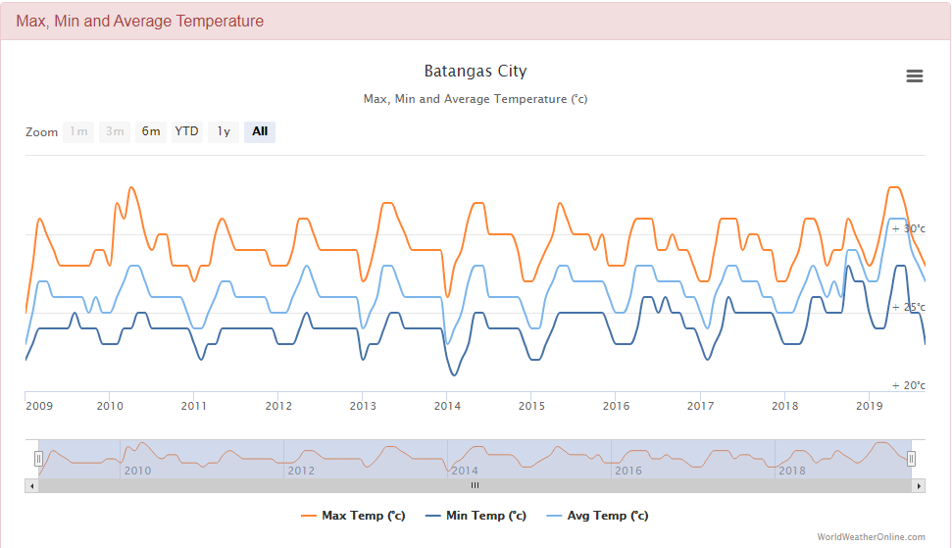

**Figure 1.0** Temperature Variance From

Previous Years in Batangas City

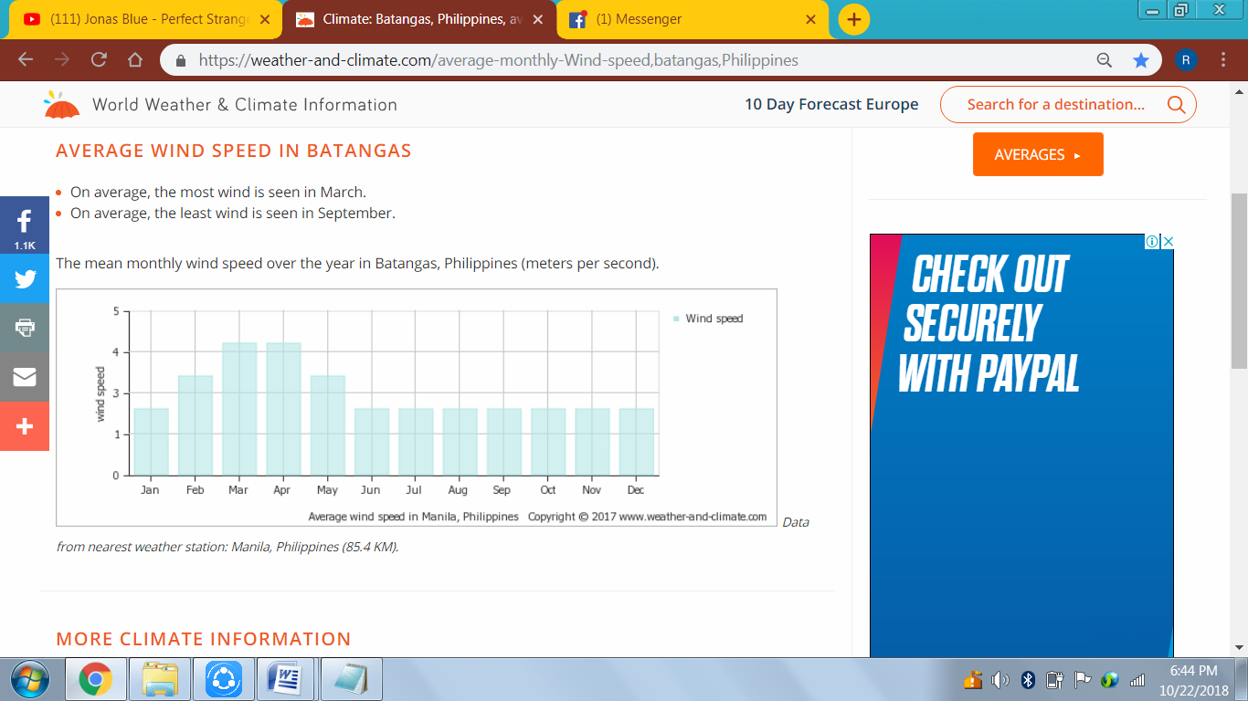

**Figure 2.0** Wind Velocity in Batangas City Throughout a Year

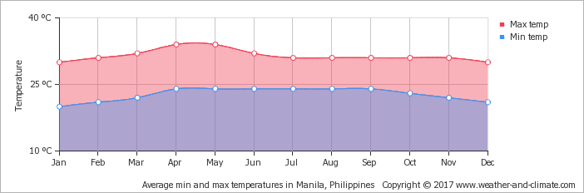

**Figure 3.0** Relative Temperatures in Batangas City throughout a Year

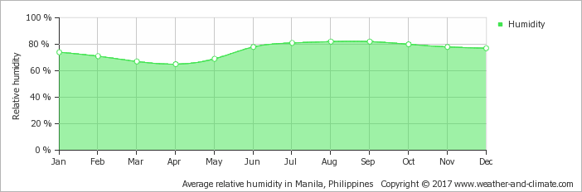**Figure 4.0** Relative Humidity in Batangas City throughout a Year

Data gathered above was the basis for the outdoor and indoor condition of the mixed use building. The average temperature for dry bulb, wet bulb, indoor condition, average temperature and relative humidity had been used.

**Project Location and Design Building Orientation**

I. Climatic Condition of the Locality as to where the building is constructed.

The climatic condition in Batangas City for the summer design conditions is as follows:

* 1. Latitude = 13.7573° N latitude
  2. Longitude = 121.0517° East longitude
  3. Solar haze factor = 0; negligible
  4. Outdoor Conditions

4.1 Maximum dry bulb temperature, tDB = 35° C

4.2 Maximum wet bulb temperature, tWB = 26° C

* 1. Indoor Conditions

5.1 Dry bulb temperature tDB = 25° C

5.2 Relative humidity = 50%

* 1. Daily range in the locality = 10° C

II. Building Orientation

The building is to be located at Batangas-Tabangao-Lobo Rd., Barangay Pallocan West, Batangas City. The front elevation of the building is facing east and the rear is facing west.

* Location Map

Using the google earth application, the location map of the proposed site viewed by satellite is shown in Figure 5.0. It has a total perimeter of 171 m and total area of 1819 m2.

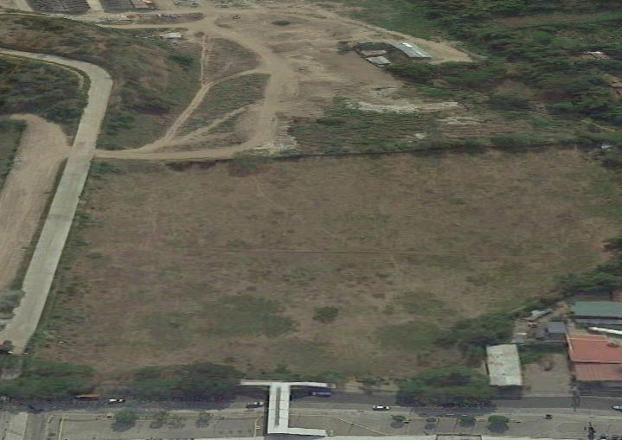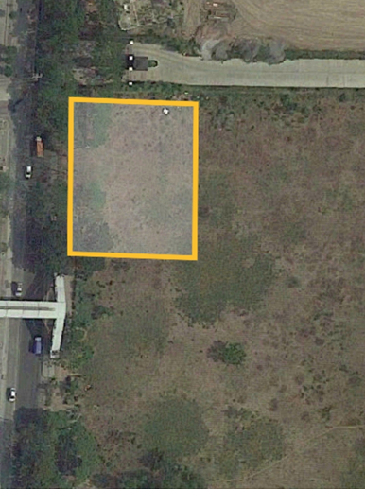

**Figure 5.0** Location Map of Barangay Pallocan West,

Batangas City by Google Earth

III.Building Representation

This section shows the 2D model of a three storey hospital building at Barangay Pallocan West, Batangas City. It includes the top view of each floor of the hospital.

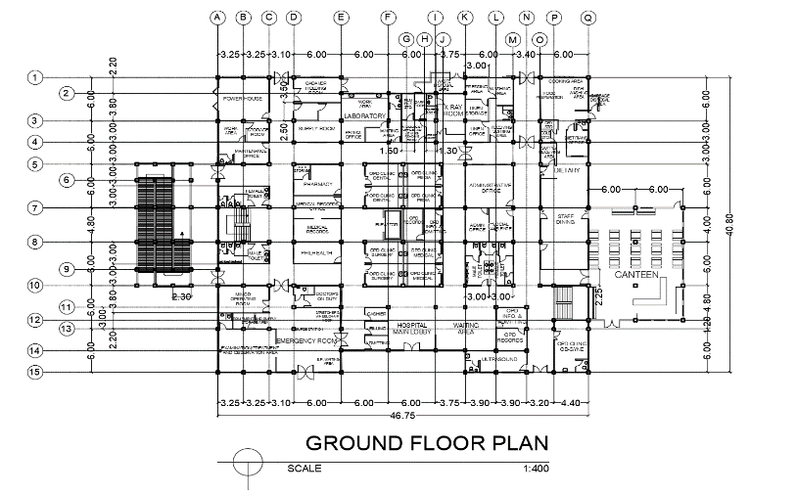

**Figure 6.0** Top View of the Ground Floor

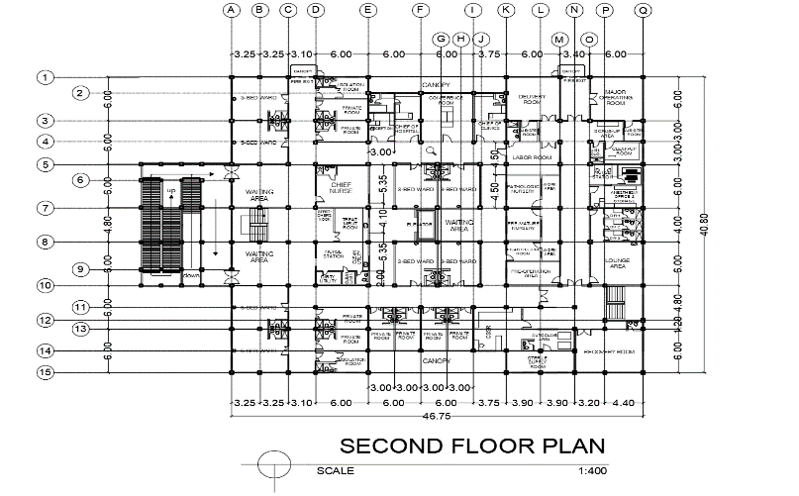

**Figure 7.0** Top View of the Second Floor

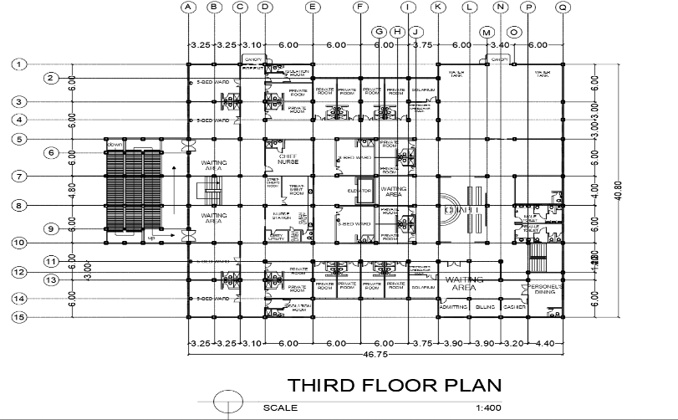

**Figure 8.0** Top View of the Third floor